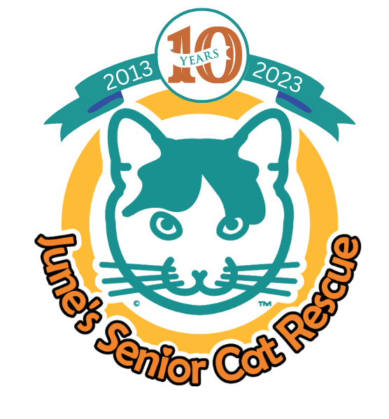
June’s Senior Cat Rescue Board of Directors Application

If you are interested in becoming a member of the Board of Directors of June’s Senior Cat Rescue (JSCR), please send a completed application and résumé via email to: info@humanenetwork.org with JSCR Board Application in the subject line. If you have questions, please email them to this same address.

Contact Information

Name: ______________________________________________

Address (including zip code):__________________________________________________________
Phone #s (cell and/or other number best to reach you):_____________________________________

Email:__________________________________________________________

Please attach a current résumé or CV.

Questions. Please feel free to use additional space.

1. Why do you want to serve on the JSCR Board of Directors?

2. Have you previously served, or are you currently serving, on other nonprofit boards? Please elaborate.

3. What is your current or recent past connection to JSCR (past or current volunteer, adopter, former staff, donor, etc.)? If past or former, please share why the relationship ended.

4. Please describe your management and/or leadership experience and any specific skills, experience, or background that you would bring to JSCR.

5. Please elaborate on any other areas of expertise you possess that you would be willing to use to help JSCR. (Examples: animal welfare/sheltering/rescue experience, legal, human resources, fundraising, financial/accounting, marketing, event planning, etc.)

6. Are you able to meet the board requirements listed in the accompanying document?

7. Do you have any questions for us? Please elaborate.

8. Is there anything else you would like to share?

References: Please list three references we can call who can speak to your professional or volunteer experience and performance. Provide their name, email address, and phone number and be sure to note how you know this individual. Please avoid using relatives as references.

Thank you so much for your interest in the JSCR Board and for taking the time to reach out to us.

