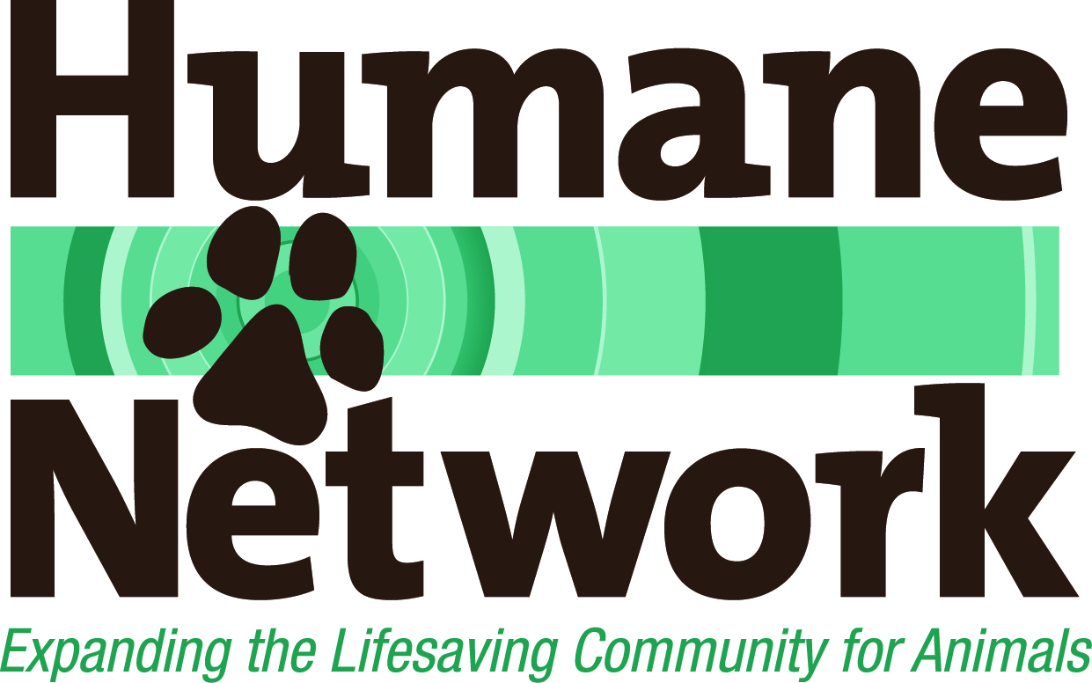
Approximate Timeline for Recruitment

Estimated Timeline for Recruitment Project
The process itself can be customized to meet the needs of the organization. Please bear in mind that this time line is an estimate and that actual times may vary for a variety of reasons.
Ongoing
- Conference calls or e-mail status updates
- Periodic review of overall process to be sure advancing efficiently and effectively

 | Task | Estimated Hours | Estimated Duration
Step 1 | Developing Recruitment Materials and Conducting Salary/Benefits Survey  - Discussions with leadership, as needed, to determine:  - Expectations, core competencies needed for success in the role, negotiable and non-negotiable qualifications  - Target dates  - Salary survey to assist with setting appropriate salary range  - Creation OR update of past materials:  - Job description  - Recruitment/Marketing package  - Deliverables include:  - Job description  - Recruitment/Marketing package  - Recruitment schedule with target dates for each step | 5 – 20 hours | 2 – 3 weeks  Variables include response time for review and approvals by hiring committee or board
Step 2 | Posting Opening  - Provide a list of posting options (free and for fee) and post opportunity to all selected websites or other advertising venues  - Targeted active recruitment of qualified candidates using Humane Network contacts or board contacts as desired  - Deliverable:  - List of postings | 8 – 25 hours Organization pays for any approved posting fees | 1 to 1.5 weeks for postings to appear online or in print  Recruitment is ongoing for designated time frame (see below)
Step 3 | Tracking and Assessing Applicants  - Tracking of all applicants, including their resumes and any other supporting materials  - Sending acknowledgement of receipt of resume to each applicant and subsequent correspondence  - Screening of candidates  - Reviewing and assessing resumes  - Brief (30 – 45 minute) screening interviews over the phone with all candidates that appear to have reasonable or strong qualifications  - Online research of candidates (news stories, social media, etc.)  - Providing copies of application packages  - Assessment of experience, skills and fit relevant to position  - Recommendation of candidates to the committee for the next round of interviews with supporting documentation  - Deliverables:  - Tracking list/spreadsheet of all applicants  - Results of interviews and research on candidate tracking sheet  - List of recommended candidates to move to next round  - Candidate resumes and other supporting documents | 34 – 70 hours | 4 – 7 weeks  Based on chosen duration of opening/recruitment period. Recommend a minimum of 4 weeks for position to remain open and for recruitment time.
Step 4 | Coordinating Interviews and Selection Process  - Customized selection process which may include an additional round of more in-depth phone interviews to be conducted by HN or search committee  - Collection and review of work products as appropriate (e.g. writing samples, etc.)  - Reference checks  - Background checks (fees apply)  - Interview forms and recommended questions for the interview team for each round of interviews (Skye/phone, final in-person)  - Arrangement of Skype/phone and final in-person interviews (as needed)  - Development of schedules for in-person visit/interviews (recommend shelter tour, panel interview by selected staff and full board interview)  - Follow-up communication with candidates (including making initial offer, assisting with negotiations and notifying those who are declined)  - Facilitation and guidance through the selection/decision-making process, as much or little as desired  - Review/assess current status with president or search committee  - Skype participation in the in-person final candidate interviews by one of the consultants, if desired  - Deliverables:  - Interview forms/questions  - Skype/phone and in-person interview schedules  - List of recommended candidates updated at each stage  - Candidate resumes and other supporting documents for interview team | 30 – 50 hours | 1 – 4 weeks  Variables include response time for committee candidate review, interviews and decision-making.
Step 5 | Coordinating Hiring Process  - Managing communication with chosen candidate, if desired, including negotiating the offer, start date, etc.  - Assistance with the on-boarding process, if desired  - Deliverables:  - New hire package, if applicable  - On-boarding schedule, if applicable | 5 – 15 hours | 4 weeks – 2 months  Variables include duration of negotiations, relocation/availability of person hired
 | TOTAL | 82 – 180 hours | 3 – 6 months

