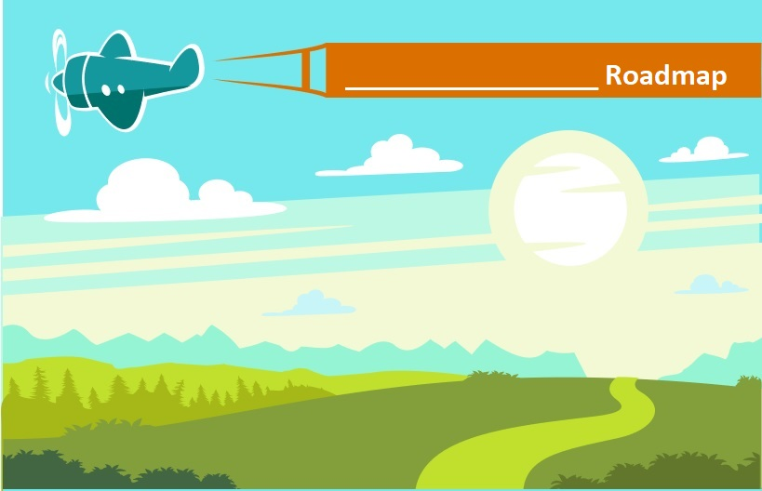
Road Map Planning Worksheet
Part 1
Our Focus and Mission
Where we are now:
What’s working well?

What’s not working well?

What would make the biggest difference?

What prevents us from making improvements? (barriers)

What do we do better than other any other groups in our area?

Community Needs: The needs of animals in our community now.

Purpose: Why our organization exists.

Where do we want to be in 3 (or 5) years?

Future Focus: Where should we put our effort and attention?

Current Mission Statement: | (insert your current mission statement here)
Accurately captures what we are trying to achieve now. | □ Yes □ No
Explains what we do in a way that inspires other to support it. | □ Yes □ No
I feel enthusiastic and inspired by our mission. | □ Yes □ No
If you or others answered no to any of these above questions, it is worth revising your mission statement.
Mission Statement Drafts: Need to concisely explain—
What you do.
Why you do it.
How you do it.
What sets you apart and inspires others to support your work.
Revised Mission Statement

Our Goals
What do you need to do to achieve your mission?

What should you focus on during the course of the next year to move your organization closer to achieving your mission?

List your ideas. Place a check mark next to or circle your top 5.
Goal 1
__Specific __Measurable __Achievable __Relevant __Time-bound

Goal 2
__Specific __Measurable __Achievable __Relevant __Time-bound

Goal 3
__Specific __Measurable __Achievable __Relevant __Time-bound

Goal 4
__Specific __Measurable __Achievable __Relevant __Time-bound

Goal 5
__Specific __Measurable __Achievable __Relevant __Time-bound

