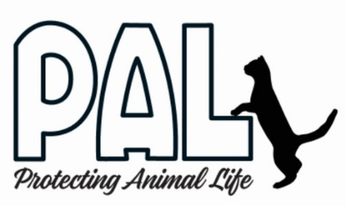
PALnv
Board of Directors Application

If you are interested in becoming a member of the Board of Directors for PALnv, please send a completed application and resume via email info@humanenetwork.org with PALnv Board Application in the subject line. If you have questions, please email them to this same address.

Contact Information

Name: ______________________________________________

Address (including zip code): __________________________________________________________
Phone (cell*): _____________________________________________________________________
(* or other number(s) at which best to reach you)

Email: __________________________________________________________

Please attach a current resume.

Please answer the following questions and feel free to use additional space as needed.
1. Why do you want to serve on the PALnv Board of Directors?

2. Have you previously served, or are you currently serving, on other nonprofit boards? Please elaborate.

3. What is your current or recent past connection to PALnv (past or current volunteer, adopter, former staff, donor, etc.)? If past or former, please share why the relationship ended.

4. Please describe your management and/or leadership experience and any specific skills, experience, or background that you would bring to PALnv.

5. Please elaborate on any other areas of expertise you possess that you would be willing to use to help PALnv. (Examples: animal welfare/sheltering/rescue experience, legal, human resources, fundraising, financial/accounting, marketing, event planning, etc.)

6. Are you able to meet the board requirements listed in the accompanying document?

7. Do you have any questions for us? Please elaborate.

8. Is there anything else you would like to share?

References: Please list three references we can call who can speak to your professional or volunteer experience and performance. Please provide name, email address and phone number, and be sure to note how you know this individual. Please avoid using relatives as references.

Thank you so much for your interest in the PALnv Board and for taking the time to reach out to us.

